# CS 255 System Design Document Template

## UML Diagrams

### UML Use Case Diagram

This is the DriverPass use-case diagram. It shows an overview of the most important activities the system will perform and who will interact with the activities and processes. On the left side are the external users, which will mainly consist of new and existing customers/ students. On the right side are the internal users, which will be the owner of the company and all the employees; ranging from CTO and IT administrator to the driving trainers and the secretary who can enter student information and schedule on-the-road training hours.

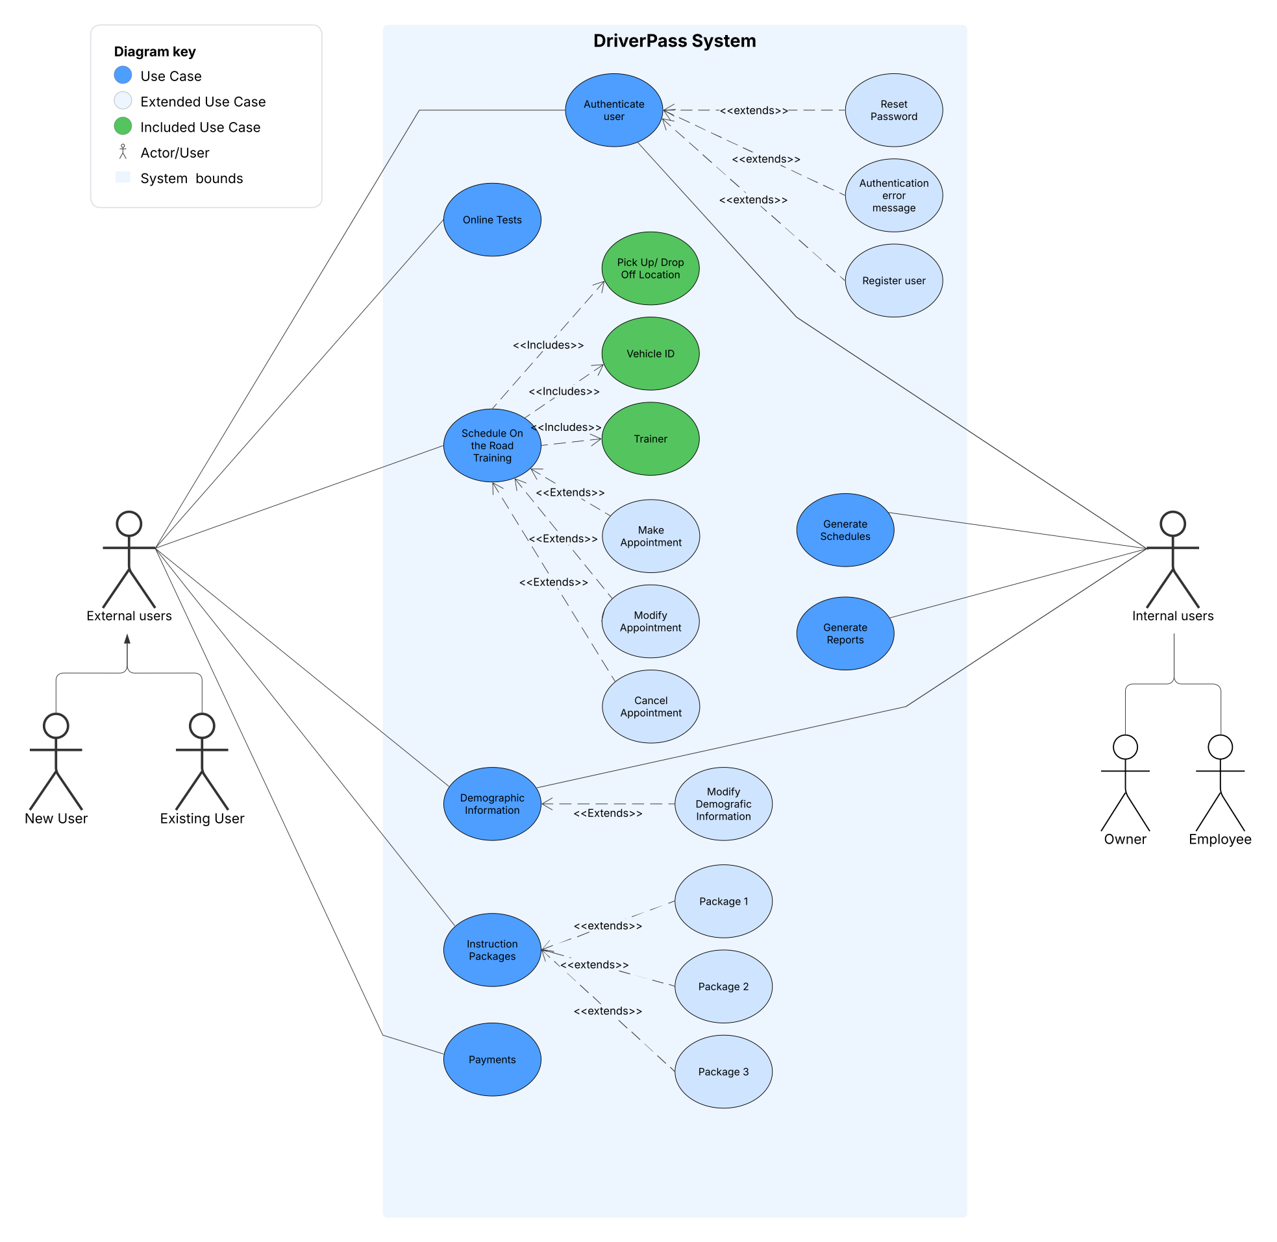

### UML Activity Diagrams

This is a UML activity diagram for the use-case Authenticate User. It starts with the user accessing the Welcome screen, which gives the user three choices: Register New User, Existing User Login, and Reset Password. Those choices will lead the user through the appropriate steps and will lead through to the authentication step. At the authentication step, entering the incorrect login or password would lead to the choices that will take the user either back to the user login screen or reset password screen. Upon correction entry of login and password, the user will be taken to the user screen.

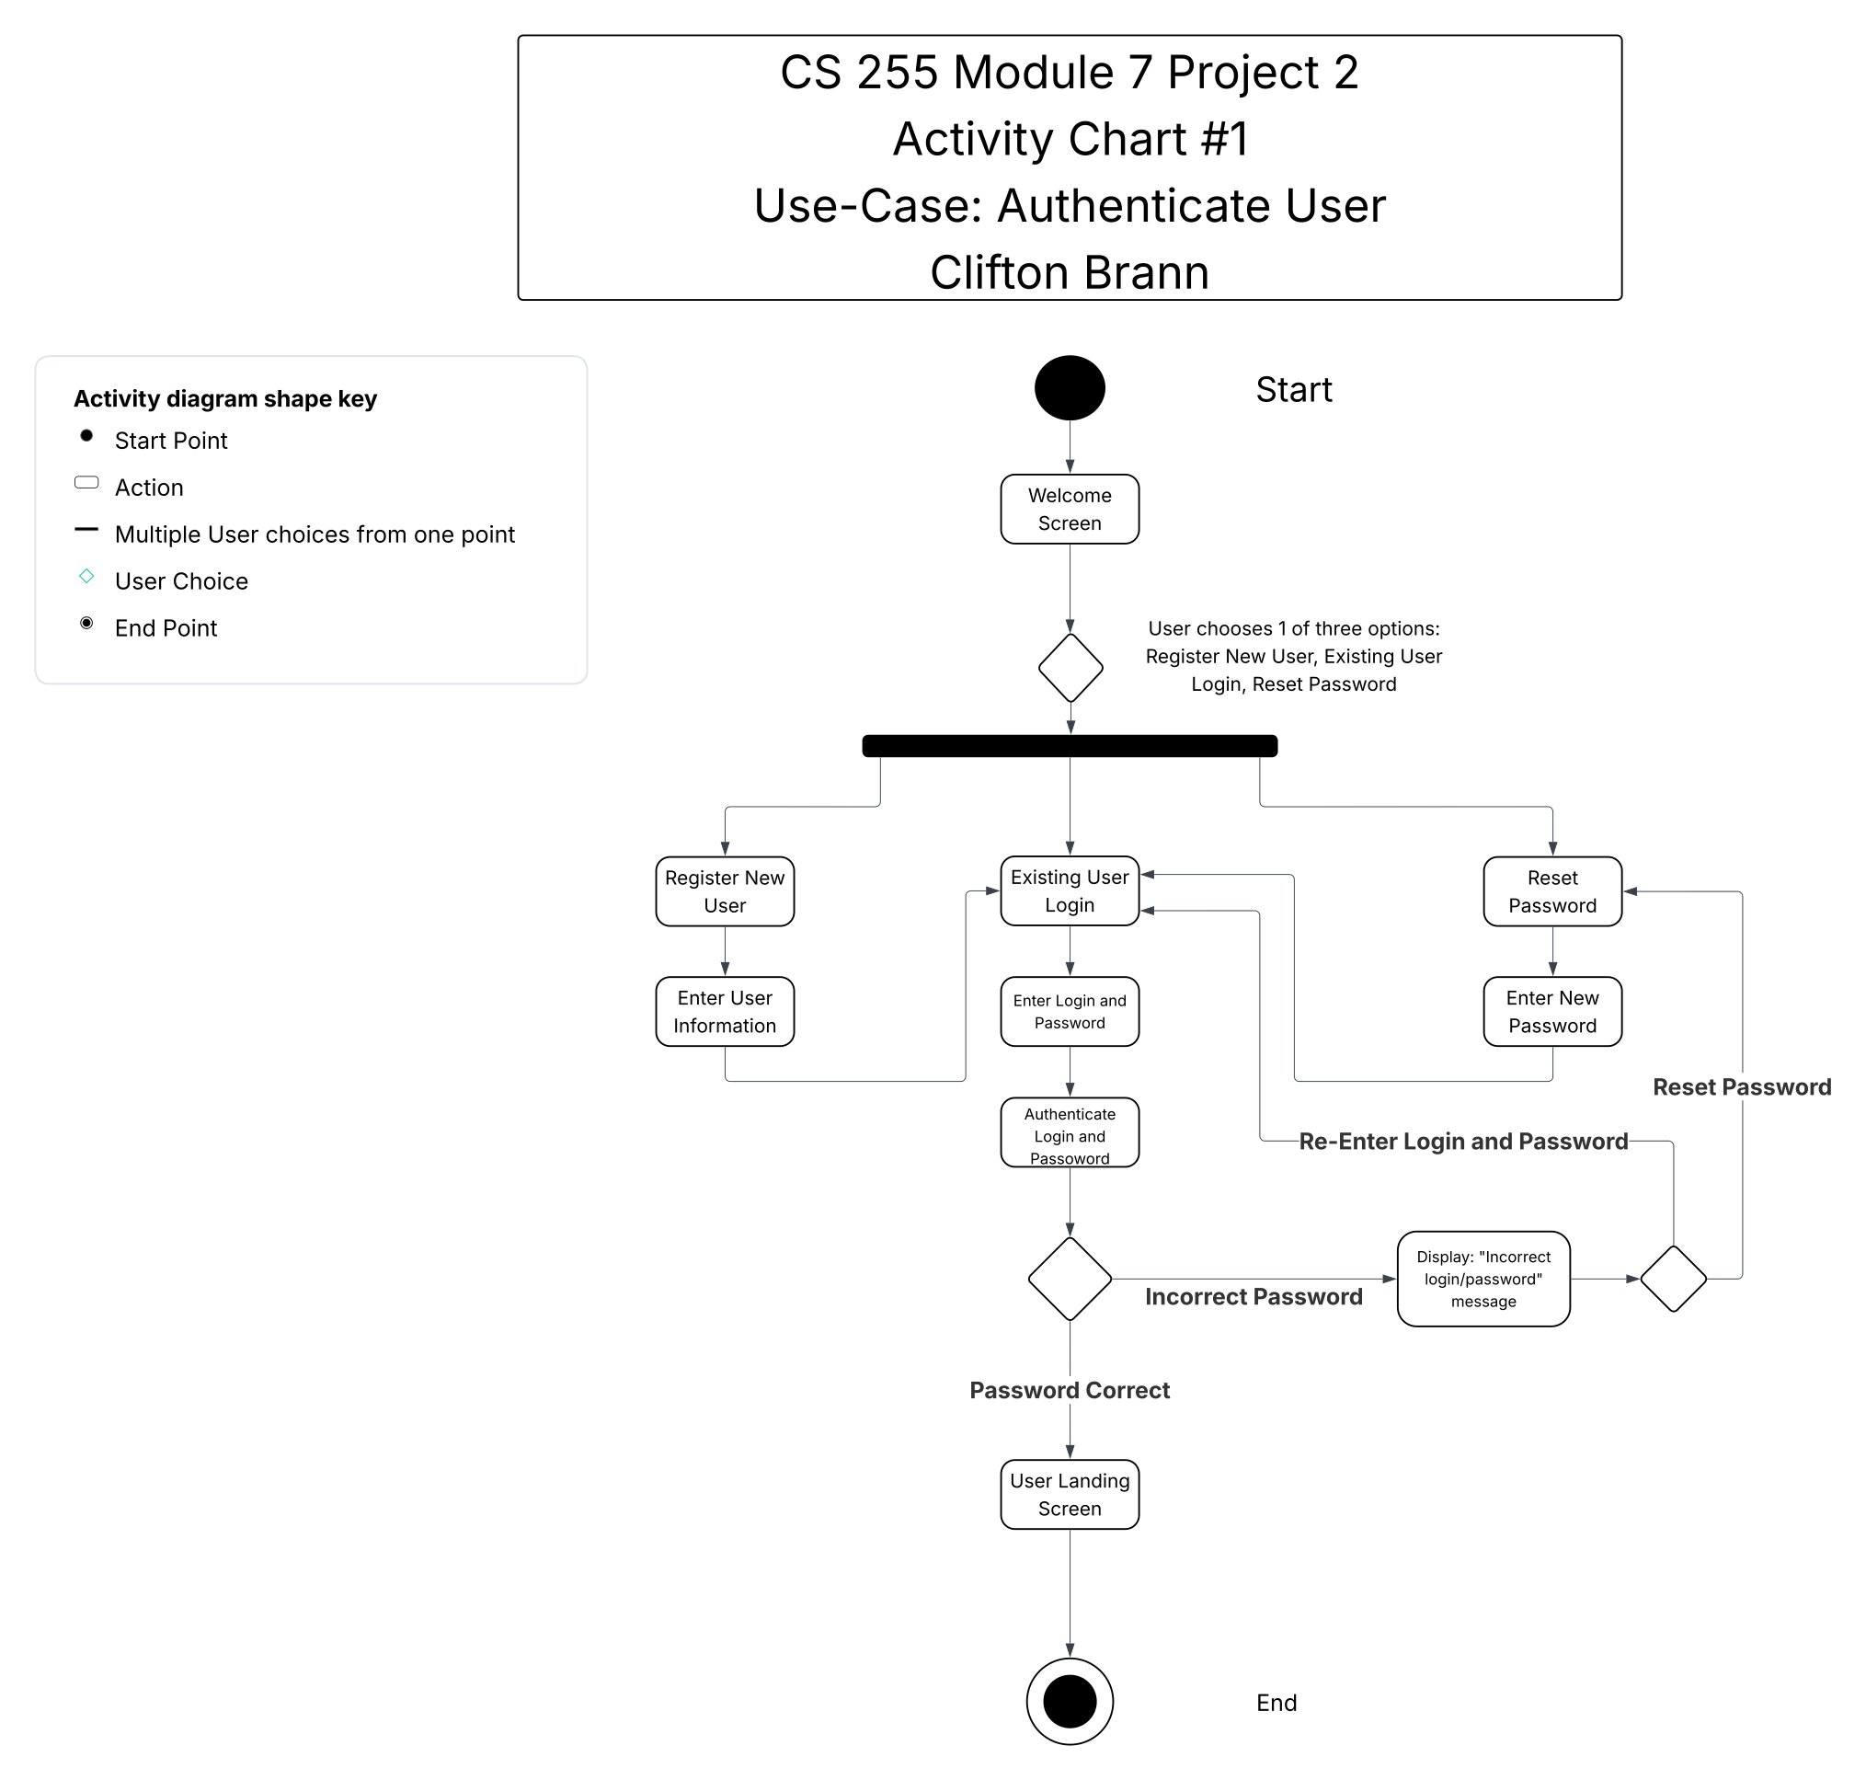

This UML activity diagram shows the steps a user will go through when scheduling an on-the-road training session. The user will also have the option to cancel or modify existing appointments.

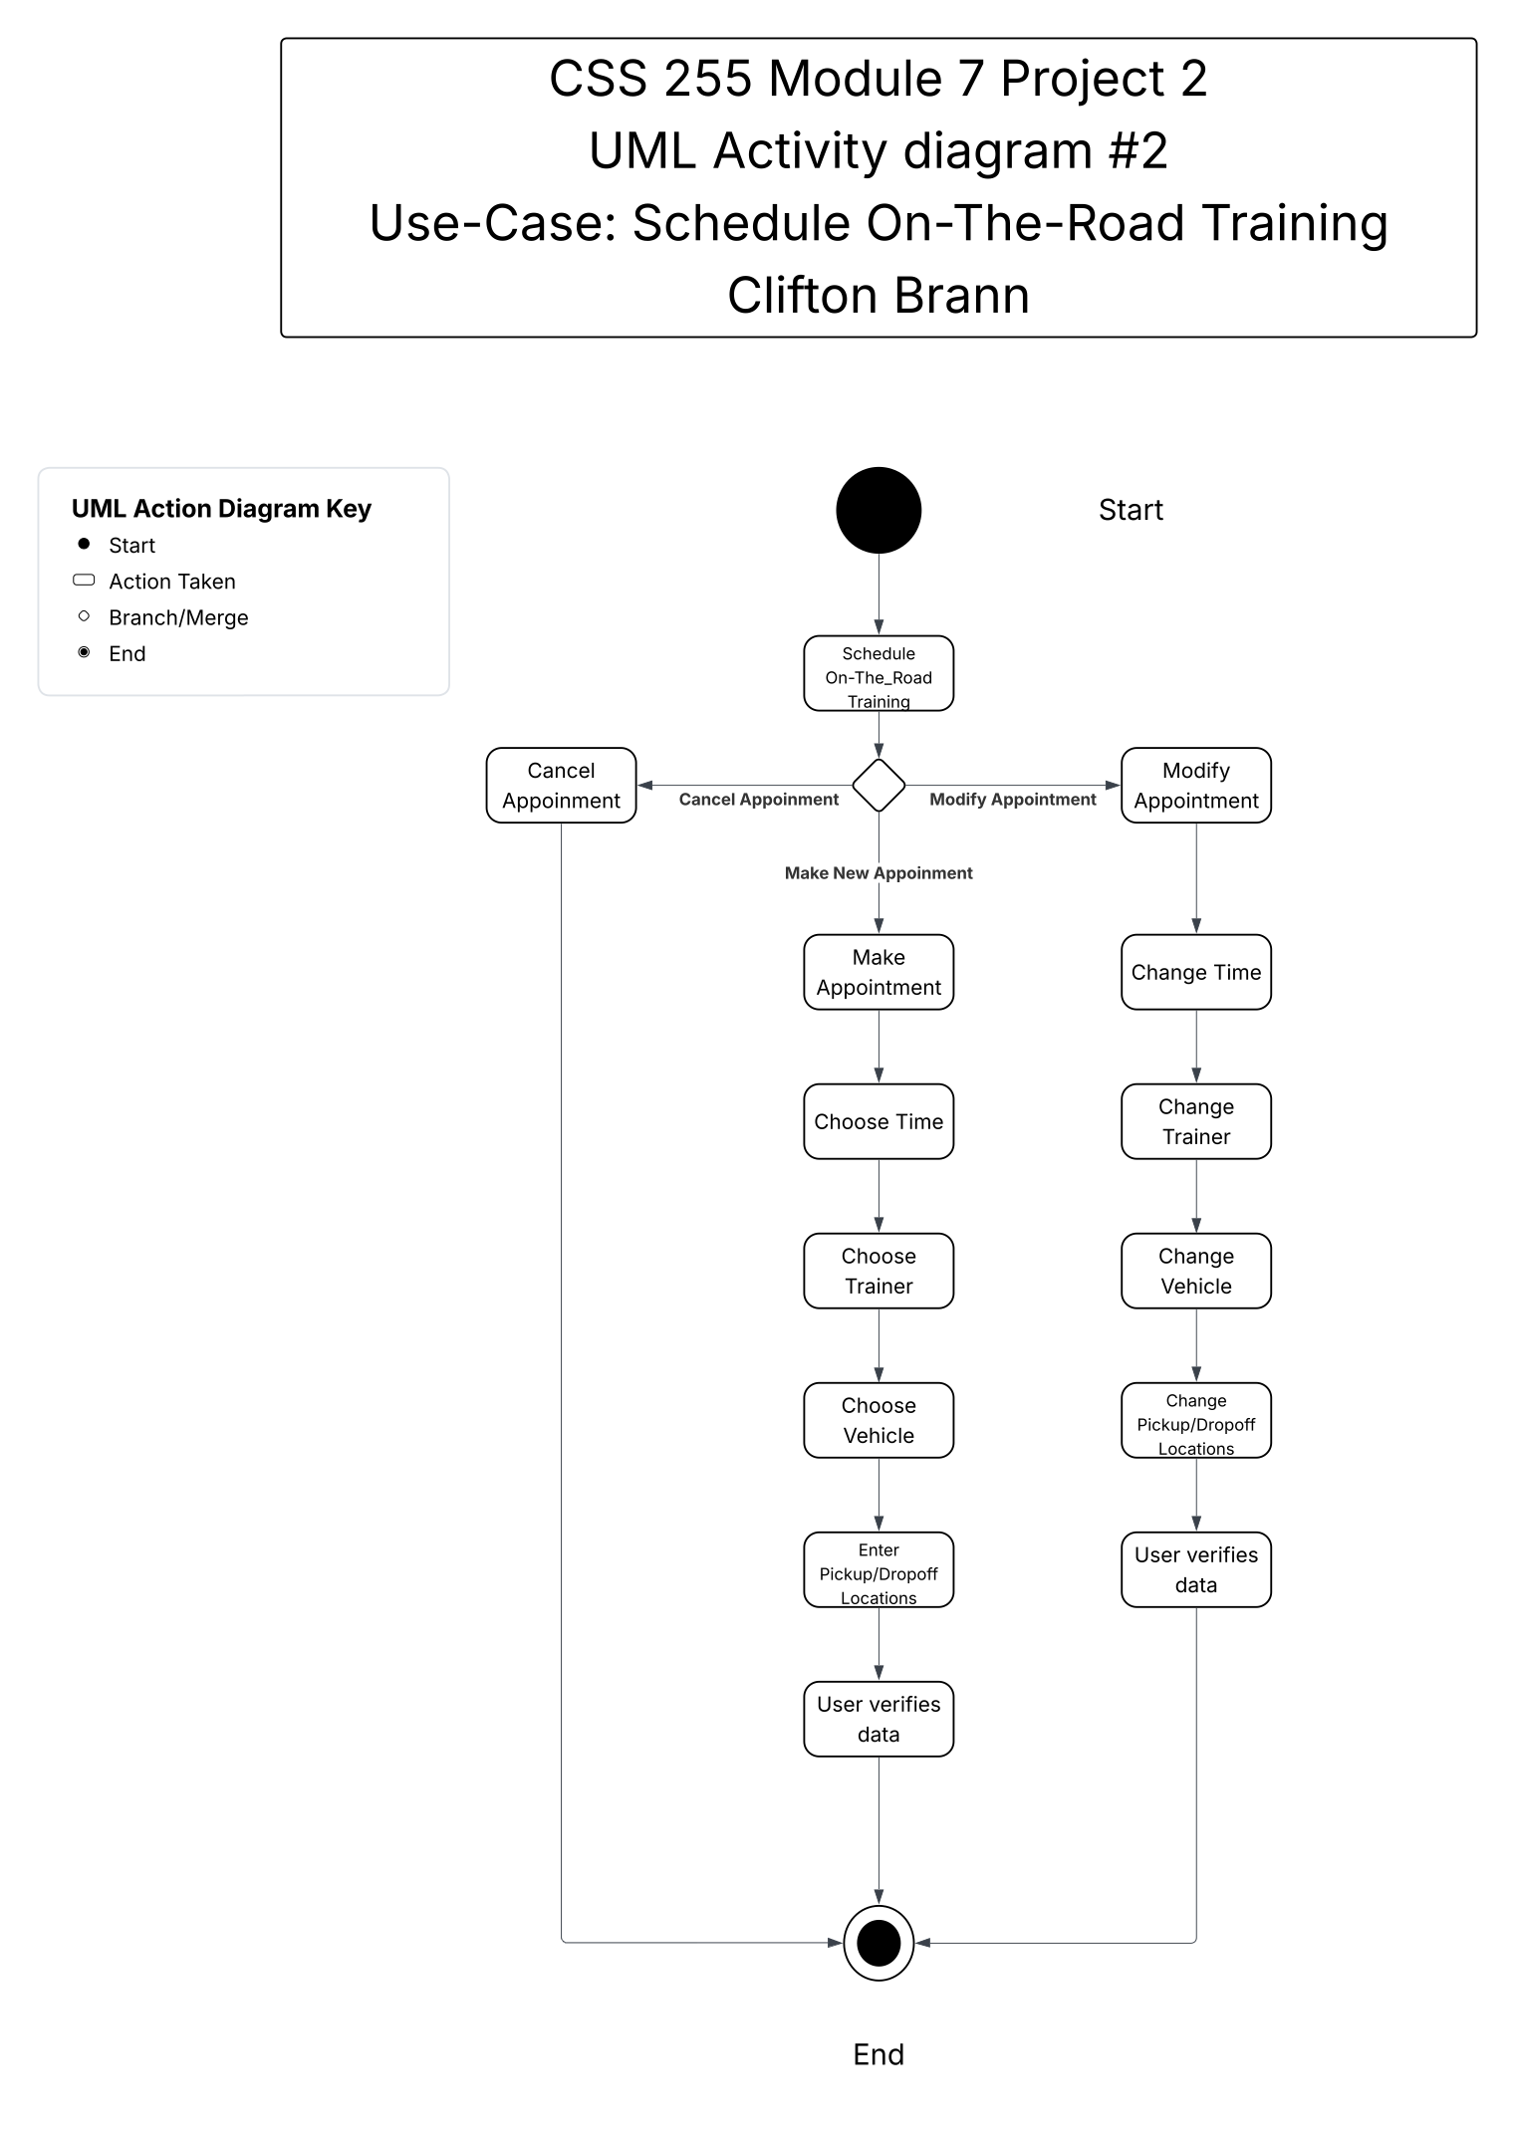

### UML Sequence Diagram

This is the sequence for an Existing User to log in. The user will access the Login Screen, also called the Welcome Screen. The user will enter their credentials, and the credentials will be authenticated by the system. If the login and password are correct, the system will grant access to the user screen. If the login attempt fails, the user will be prompted to re-enter their credentials or reset their password. In both options, the user will be redirected to the login screen to re-enter their credentials and attempt to log in to the system again.

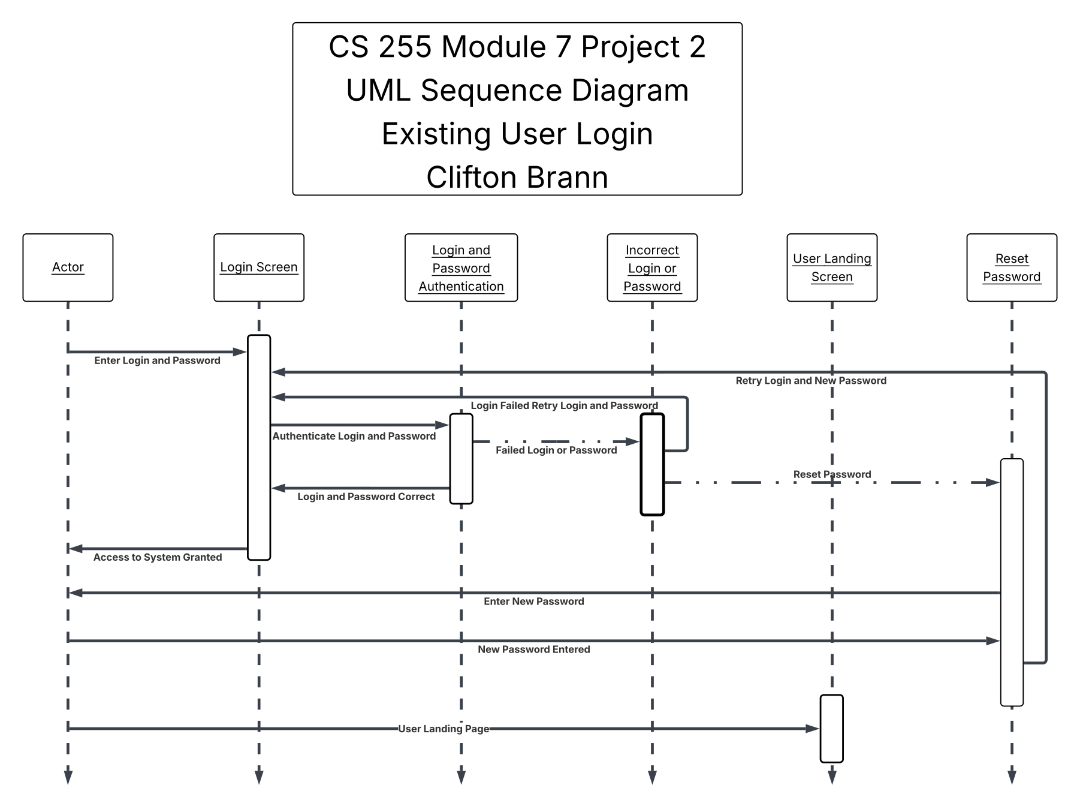

### UML Class Diagram

This is the class diagram for the DriverPass project. It contains the classes and attributes for the system.

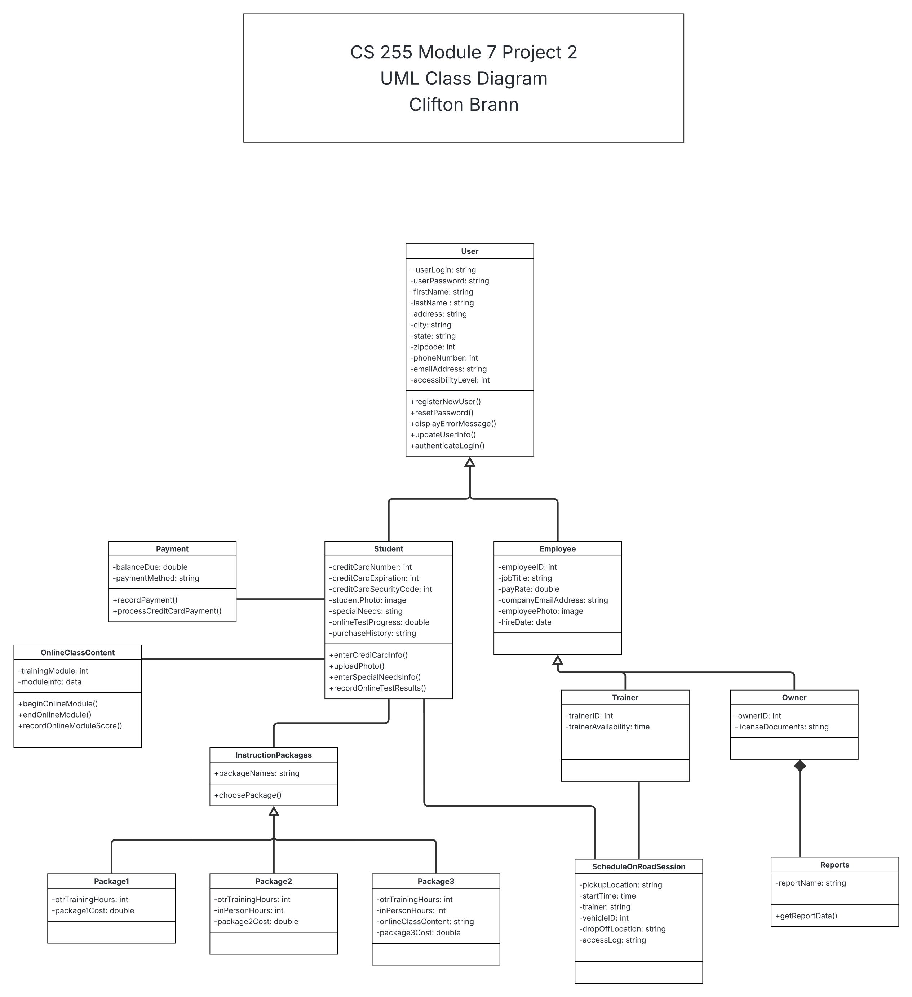

## Technical Requirements

Hardware Requirements

* Cloud-based servers
* Cloud-based database storage
* Firewall
* Routing equipment
* Onsite data backup server
* Backup power supply
* High-speed and high-capacity Internet connection

In-office Wi-Fi hardware or Ethernet connections

Software Requirements

* Windows-based server software
* SQL database management software
* Security suite to authenticate users and safeguard data, and prevent hacking and cyber attacks
* Payment processing - Square, PayPal, GoDaddy
* Encryption software for payment information storage and secure data transmission

Tools

* Suitable IDE for coding, debugging, and maintenance (Eclipse, Visual Studio Code, Xcode)
* Automated testing, deployment, and system maintenance systems
* Interface support to access and manage DMV updates

Infrastructure

* Remote datacenter
* Wi-Fi access in office
* Cellular or mobile data access outside the office
* Desktop or laptop computers or mobile devices capable of accessing the Internet
* In-house backup server
* Network equipment like routers, switches, firewalls